Q1. Explain using code examples what is meant by props and state in React JS?
State in react refers to a components local state, this is the information associated with a component that can only be accessed within the component, eg Local Variable values.
Props are values passed to a component by their parent component, they allow us to make react components reusable and configurable. Below shows a printing component, which uses props to print the value passed by the parent component.

class PrintComponent extends React.Component {
render() {
return <span>Value: {this.props.value}</span>;
}
}

Q2. In functional programming, what does the term functor mean? Can you give an example in Javascript?
A functor is a data object which is mappable, this means that unary operations such as toUpperCase can be applied via data mapping. In the example below we are using an array as a functor with the .map() function.

var array = ['dom', 'lun', 'mar', 'mer', 'gio', 'ven', 'sab'];
var upperCasedArray = $.map(array, String.toUpperCase);

Q3. We have looked at three kinds of asynchronous programming mechanisms, namely callbacks, promises and streams. Mention one advantage and one disadvantage of each type

The advantages of using streams comes when implementing series such as a series of requests to an API eg. a search bar or other requests that don’t involve individual finite requests. It also implements all of the functionality of promises and is cancelable.
The main disadvantage of this over promises is that for single requests such as above it can be an overcomplication to implement a data stream.

The main advantage of using a promise, is that it’s simple and completely vanilla JS requiring no external libraries. For single requests it often makes more sense to use a promise for readability purposes over a stream.
The disadvantage of this, is promises don’t scale well and a stream is better suited to a series of requests.

Q4. With the aid of a diagram and example code, describe the Cascading Style Sheets (CSS) Box Model and show how it can be used to space DOM elements

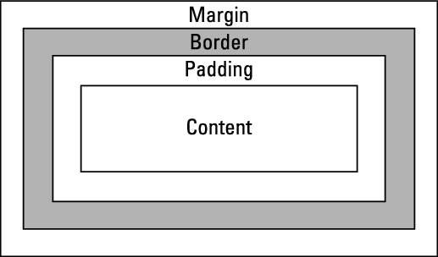

The CSS box model refers to the metaphorical box that surrounds each HTML element, this box has a border which refers to the lines outlining the box, a margin which refers to the space between the border and any elements the box is within and padding which refers to the space between the actual object and the border.

Q5. Detail how the browser loads and bootstraps a rich web application from an initial URL.

- URL is translated to an IP address via a DNS query
- Browser contacts webserver at the IP address and performs a HTTP GET request to retrieve the web page
- Browser begins to render Web Page, in the case of a Rich Web application a bootstrapper will load any libraries or frameworks such as react or angular from their sources and init them.
- Controller is loaded and rich web application “starts”
- CSS Styles are applied

